

NATIONAL POLICE COMMISSION

**PHILIPPINE NATIONAL POLICE, POLICE REGIONAL OFFICE CALABARZON**

**CAVITE POLICE PROVINCIAL OFFICE**

**CARMONA MUNICIPAL POLICE STATION**

J.M. Loyola Street, Brgy. Maduya, Carmona, Cavite

June 2022

2022-06-256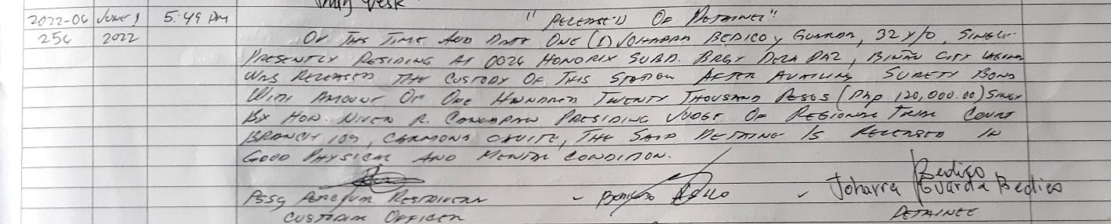

2022-06-257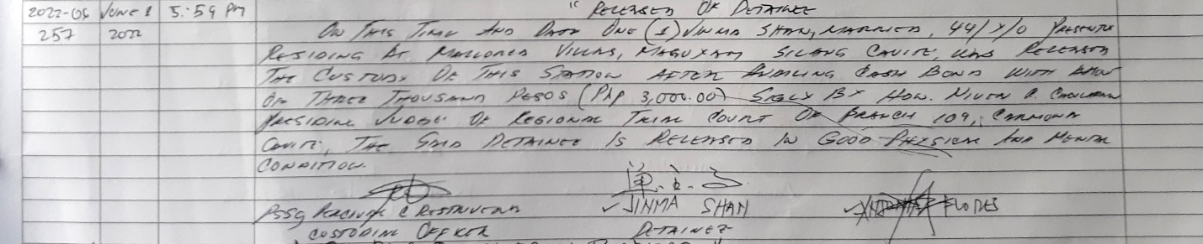

2022-06-259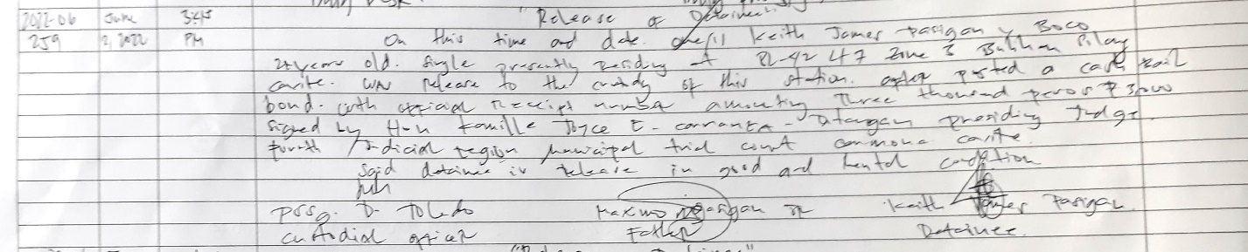

2022-06-260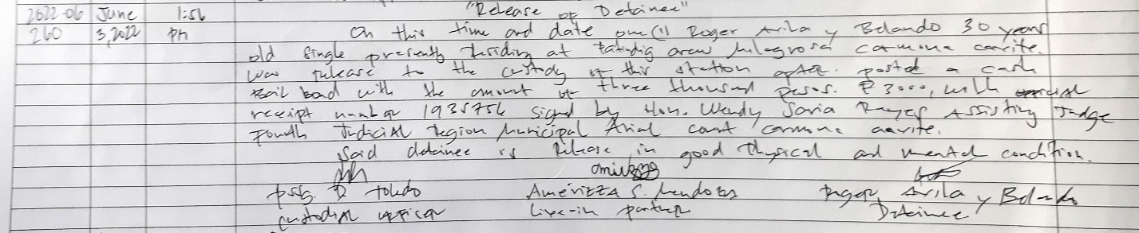

2022-06-264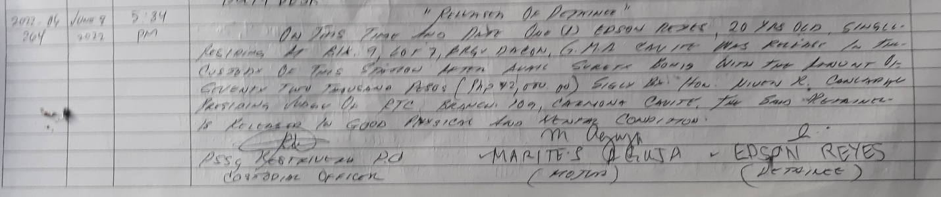

2022-06-272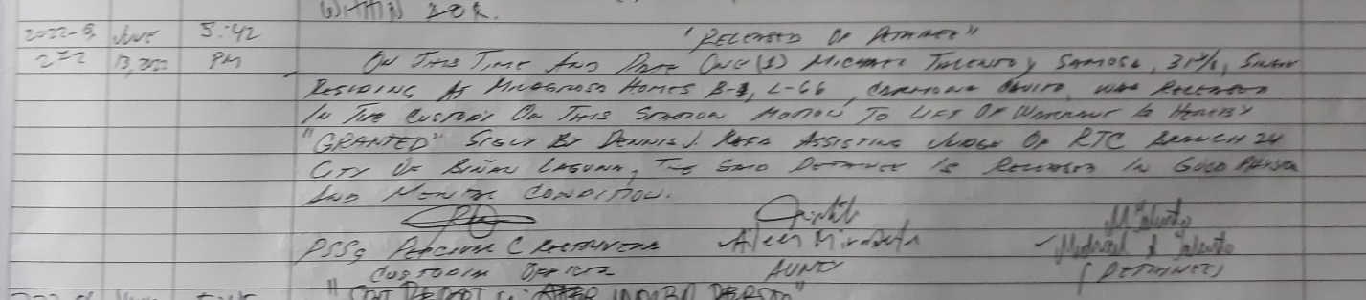

2022-06-276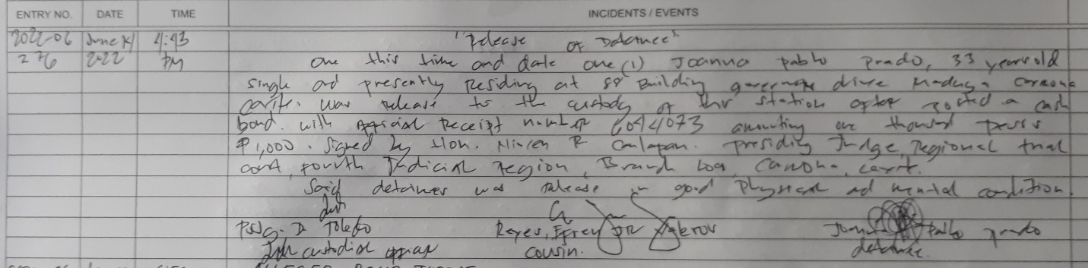

2022-06-280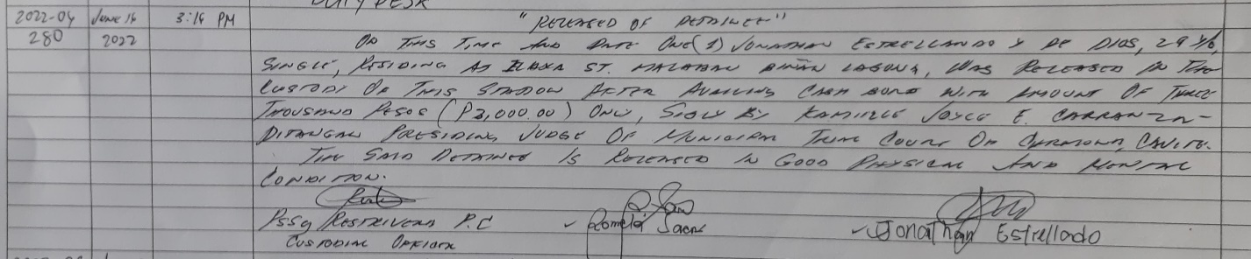

2022-06-283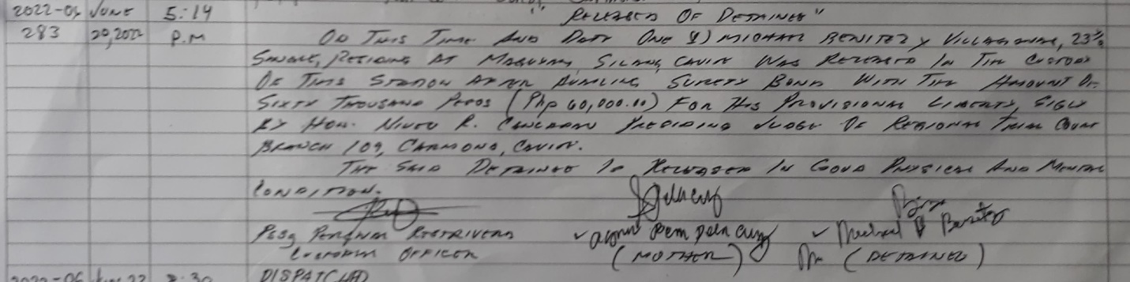

2022-06-287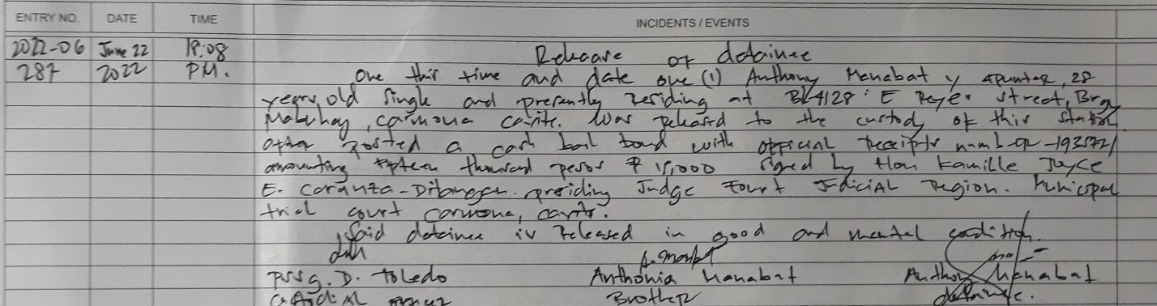

2022-06-288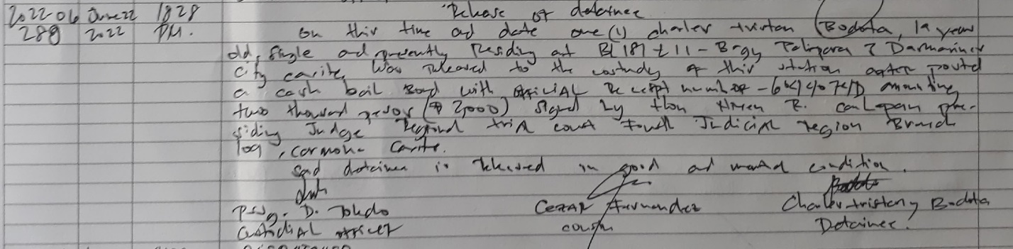

2022-06-294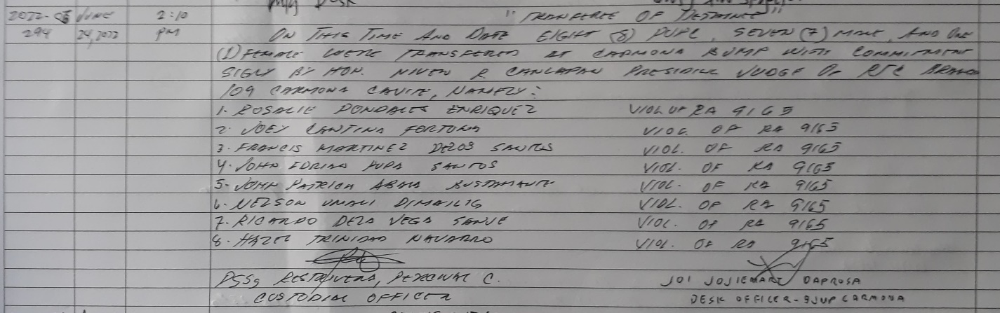

2022-06-298

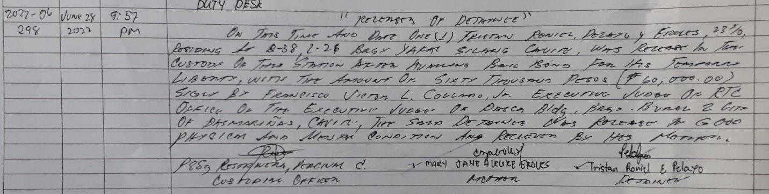

2022-06-301